**Integrated Human Practice**

In this year, human practices were integrated to the whole process of our project as the following flowchart (Fig.1).

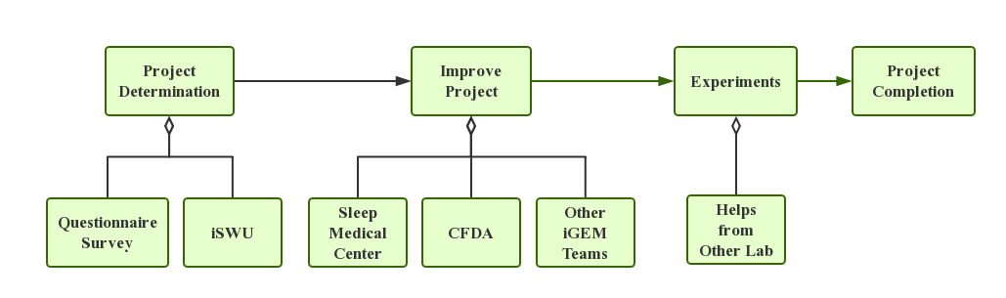

**Fig.1 Flowchart of how human practices integrated to the project.**

**Project Determination**

Our team has always focused on solving the existing issue seen in the society, and we value our connection with the vast public as well as our counterparts. For the year of 2017, we picked up two candidate projects – both of which were trying to provide possible solutions to present-day issues – one was “Rabies Vaccine Taken by Mouth” and the other was “Rhythmic Production of Melatonin in *E. coli*”. We always want to be of help of our world; so before making the final choice, we looked carefully into the potential social and scientific value of both projects, by means of initiating field survey, interview professors and experts from universities and authorities as well as collaborating with other iGEM teams.

The first project design is inspired by the suggestions from our tutors, while the second one is more closely linked to our own life. According to the shared daily experience, nowadays many people have (little) trouble with sleeping, one of the most important and dominant, yet mysterious activity in our life. For the youth, social pressure brought by both work and family may lead to irregular sleeping time or even sleeping disorder, while many elders also suffer from difficulty in falling asleep or awakening easily – problems involving sleeping has become more and more common. In order to assess the social value of solving the problem of sleeping disorders, we want to learn about how common, how influential the sleeping disorder is, what aspects of life are influenced and people’s reaction to such problems; we also expect to find the shared characteristics of people who have sleeping disorders.

We initiated **a field survey on the sleeping quality and solutions (该部分设一个可点击的链接，链接至Human Practice-Survey-Questionnairs)** to sleeping issues on the streets and via the Web. The questionnaire used in the survey contains questions considering sleeping quality of both groups having regular timetable and working at night, respectively, and the questions on solving sleeping problems and views on using medicine to improve sleeping quality. The result shows that a large portion of interviewees had sleeping problems, some of which suffered from severe symptoms; however, few figured out a way to tackle with the issues. Meanwhile, when it comes to the medicine, basic acknowledgement of traditional benzodiazepines medicines was observed, but seldom do people know about the medicine of melatonin.

To conclude, according to the survey, we regard it very meaningful and prospective to employ the synthetic biology approaches to present new solutions to the issues considering sleeping. With this knowledge as assurance, we began our design on the project tackling sleeping problems.

While we find the project on melatonin more interesting and promising, the **iSWU (该部分设一个可点击的链接，链接至Human Practice-Meetup-iSWU处)**conference led us to our final decision. iSWU is the organization consisting of all the iGEM team in the southwest of China, providing us the platform to share with each other our projects and thoughts on synthetic biology. At the conference, all of the teams introduced their project prototype and made comments on others’ designs. At the meeting, a professor from TMMU with rich experience in immunology suggested that if we do the project about the rabies vaccine, unpreventable immunology experiments would cost a lot of time and the results would be highly unpredictable as well – in a word, it would be very difficult to complete all the experiments within three months’ time. The new information tilts the balance one step more.

After carefully evaluating the advice from other team and comparing the two projects, we chose “Rhythmic Production of Melatonin in *E.coli*” because it was more practical with more predictable results, and great social and scientific value was seen in our survey.

**Project Improvement**

After determining the project, we found that there were many problems remained to solve. Therefore, we consulted teachers and experts from **Sleep Medical Center, West China Hospital (链接至Human Practices-Survey-Sleep Center)** and **China Food and Drug Administration (CFDA).** **(链接至Human Practices-Survey-Drug Administration)** What’s more, we also communicated with other iGEM teams via Skype.

During the interview with the Sleep Medical Center faculties, the professors described the mechanism of melatonin in detail as well as melatonin’s advantages over other drugs, which gave us a whole new view on melatonin. They also emphasized what to focus during the research, such as the safety issues emerged when we tried to produce *E.coli* strains secreting melatonin in human body, the dedicate relationship between the circadian rhythm of melatonin production and sleep related neural circuits and possible test on mouse *in vivo*. At the same time, to our delight the professors highly appreciated the practicality and novelty of our project. During the interview with the experts of CFDA, we got known of the national standards on melatonin in Mainland China, which drove us to focus more on legal issues and safety considerations.

We had video chat with Team Purdue to introduce our respective projects. In this video chat, their real condition simulation experiments inspired us to do some experiments to simulate growth conditions in the environment of gut. In addition, we were inspired by team “SCU-WestChina”’s modeling of constitutive promoter family to make our modeling of enzyme kinetics by ourselves, in order to achieve more efficient production of melatonin with reasonable formula of enzymes.

With the help of the Sleep Medical Center, CFDA and other iGEM teams, we finally arrived at the complete project design and improvement.

**Experiments**

During the following experiments, we encountered many problems as well; luckily, most of them were solved with our toil and others’ assistance.

SCAU-China provided LUDOX in the measurement kit, which turned out to be crucial in our InterLab experiments.

Limited to the rules of using plate reader in our public lab, we cannot use the plate reader in our public lab for continuous kinetic measurement of repressilator over 8h. Thankfully, Team “SCU-WestChina” provided us plate reader “Biotek Cytation 3 Cell Imaging Multi-Mode Reader” in their lab to finish such experiments.

During CCiC, we learned that the project of the iGEM team of Peking University was closely related to repressilator as well, so we exchanged our experience on repressilator and maintained constant communication since. After the conference, we found in our experiment that the plasmid pLPT107 cannot be transformed into the ΔclpXPMC4100 stain that was knocked out by ourselves; thus, we turned to team "Peking" immediately. Gratefully, they sent their ΔclpXP strain to us immediately and shared their experience with us. This helped us a lot in keeping our schedule.

In all of the above mentioned survey, interview, study and communication, we obtained information and assistance that pushed us forward and enabled us to complete our project step by step. Finally, through our own hard work and the generous help of others, we finished a thorough, complete project with practical value.